**Level Changes and Notes**

Level 1

* Fully Complete but needs exit sprite

Level 2 –

* Can the bounds of the game be extended outside of the 8 lanes?
* If not it needs to be re-designed
* Needs fire escape exit sprite

Level 3

* Can the trucks be animated to move side to side as moving enemies?
* Needs final manhole exit sprite.
* Can’t jump the manholes, the player collides with them even when jumping.
* Trucks with blue arrows are the ones that move. Arrow indicates direction of initial movement.
* 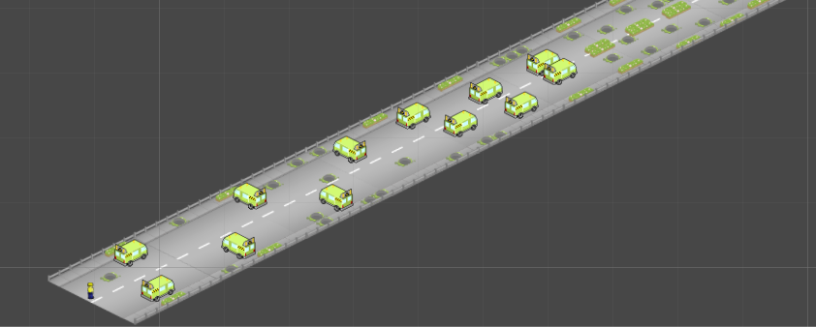

**Part 1**

**Still**

**Moving**

**Still**

* 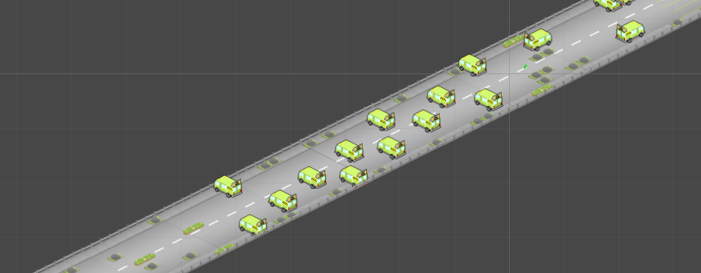

**Part 2**

**Moving**

* 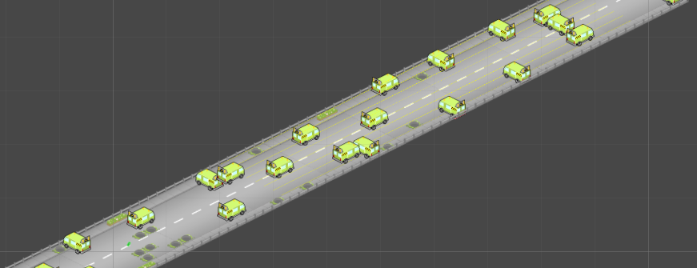

**Moving**

**Still**

**Moving**

**Still**

**Part 3**

Level 4

* Needs radioactive poo sprites to put through the level, otherwise is complete.
* Needs exit sprite (ladder?)

Level 5